Beauty & Cosmetic Interest Questionnaire

Name:__________________________________________ Date:_____________________
Phone #:_________________________ Email Address:________________________________

Please Check off the areas that interest you at this time:
Yes ___ No ___ I am interested in toning my abdomen/buttocks.
Yes ___ No ___ I am interested in non-surgical, permanent fat reduction.
Yes ___ No ___ I am interested in non-surgical options to correct fine lines/wrinkles on my face.
Yes ___ No ___ I am interested in non-surgical options to tighten loose skin on my body.
Yes ___ No ___ I am interested in maintaining healthy looking skin.
Yes ___ No ___ I would like to be contacted for further information, events and promotions.
Yes ___ No ___ Are you interested in scheduling in a complimentary consultation?

Please circle any of the following that you would like more information on:
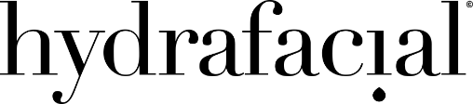
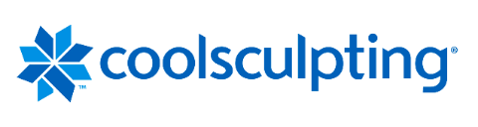
Welcome to our Office, Please Enjoy
25% off
Your First Cosmetic Service of Your Choice!

Expires 90 Days after your New Patient Visit

Cut along the dotted lines and save the bottom portion coupon to use on yourself!
Skin Tightening
Muscle Toning
Non-Surgical Fat Reduction
Facial Rejuvenation

