Third Annual Pine Street Family Practice
Motorcycle Poker Run
Sunday June 4, 2023
Rain date June 11, 2023
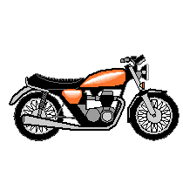
Meet at The Trio Tavern
3845 S. BHP
Williamstown, NJ 08094

Call to Register: 856-728-9749
Registration: 9:00am - 9:45 am
Kick Stands Up: 10:00 am
Scenic Route thru Southern NJ

Prizes:
Best Hand, Second Best Hand and Third Best Hand
Food, Beverages and Music upon return

Day of Poker Run: $30 per Rider and $15 per passenger
No Club Colors Permitted

All proceeds will benefit the Paul A. Van Houten, DO Memorial Scholarship Fund
given to students who are pursuing a career in medicine from the
Southern NJ area

