Aesthetic Interest Questionnaire
Name: _______________________________________________________ Date: ________________________________
Phone #_____________________________________ Email:_________________________________________________

For the following statements, please check off the areas that interest you at this time:
YES ____ NO ____ I am interested in toning my abdomen/buttocks.
YES ____ NO ____ I am interested in non-surgical, permanent fat reduction treatments.
YES ____ NO ____ I am interested in non-surgical options to correct fine lines & wrinkles on my face
YES____ NO ____ I am interested in non-surgical options to tighten loose skin on my body.
YES ____ NO ____ I am interested in maintaining healthy looking skin.
YES ____ NO ____ I would like to be contacted for further information, events and promotions
YES ____ NO ____ I have a friend or family member interested in learning more.
*Refer a friend/family member who books a treatment and receive a $25 Thank You Gift Card to Target OR Walmart*

Please circle any of the following that you would like more information on:
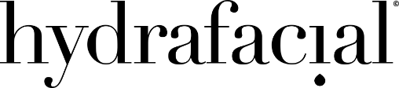  Facial Rejuvenation | 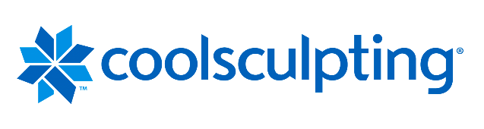  Non-Surgical Fat Reduction
Skin Tightening | 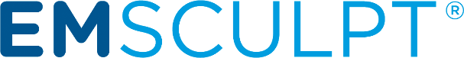  Muscle Toning

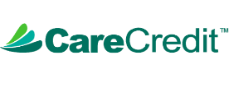
Financing Available!

Are you interested in scheduling a complimentary consultation?

YES___ NO____

